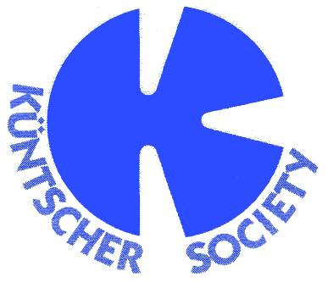
ORTHOTEMATH 2019, May 2-4th

Venue: Kallithea Chalkidiki, Athos Palace

Date: May 3th (17:00-18:30)

Topic: “Pushing limits in intramedullary nailing”

Chairs: Gradl, Friedl

15' Deformity nailing
Peter Thaller

15' Nailing around the ankle
Wilhelm Friedl

15' Tips & tricks for nailing in comminuted fractures
Roland Biber

15' Lengthening and defect reconstruction with nails
Peter Thaller

15' ​Nailing in arthrodesis
​Georg Gradl

